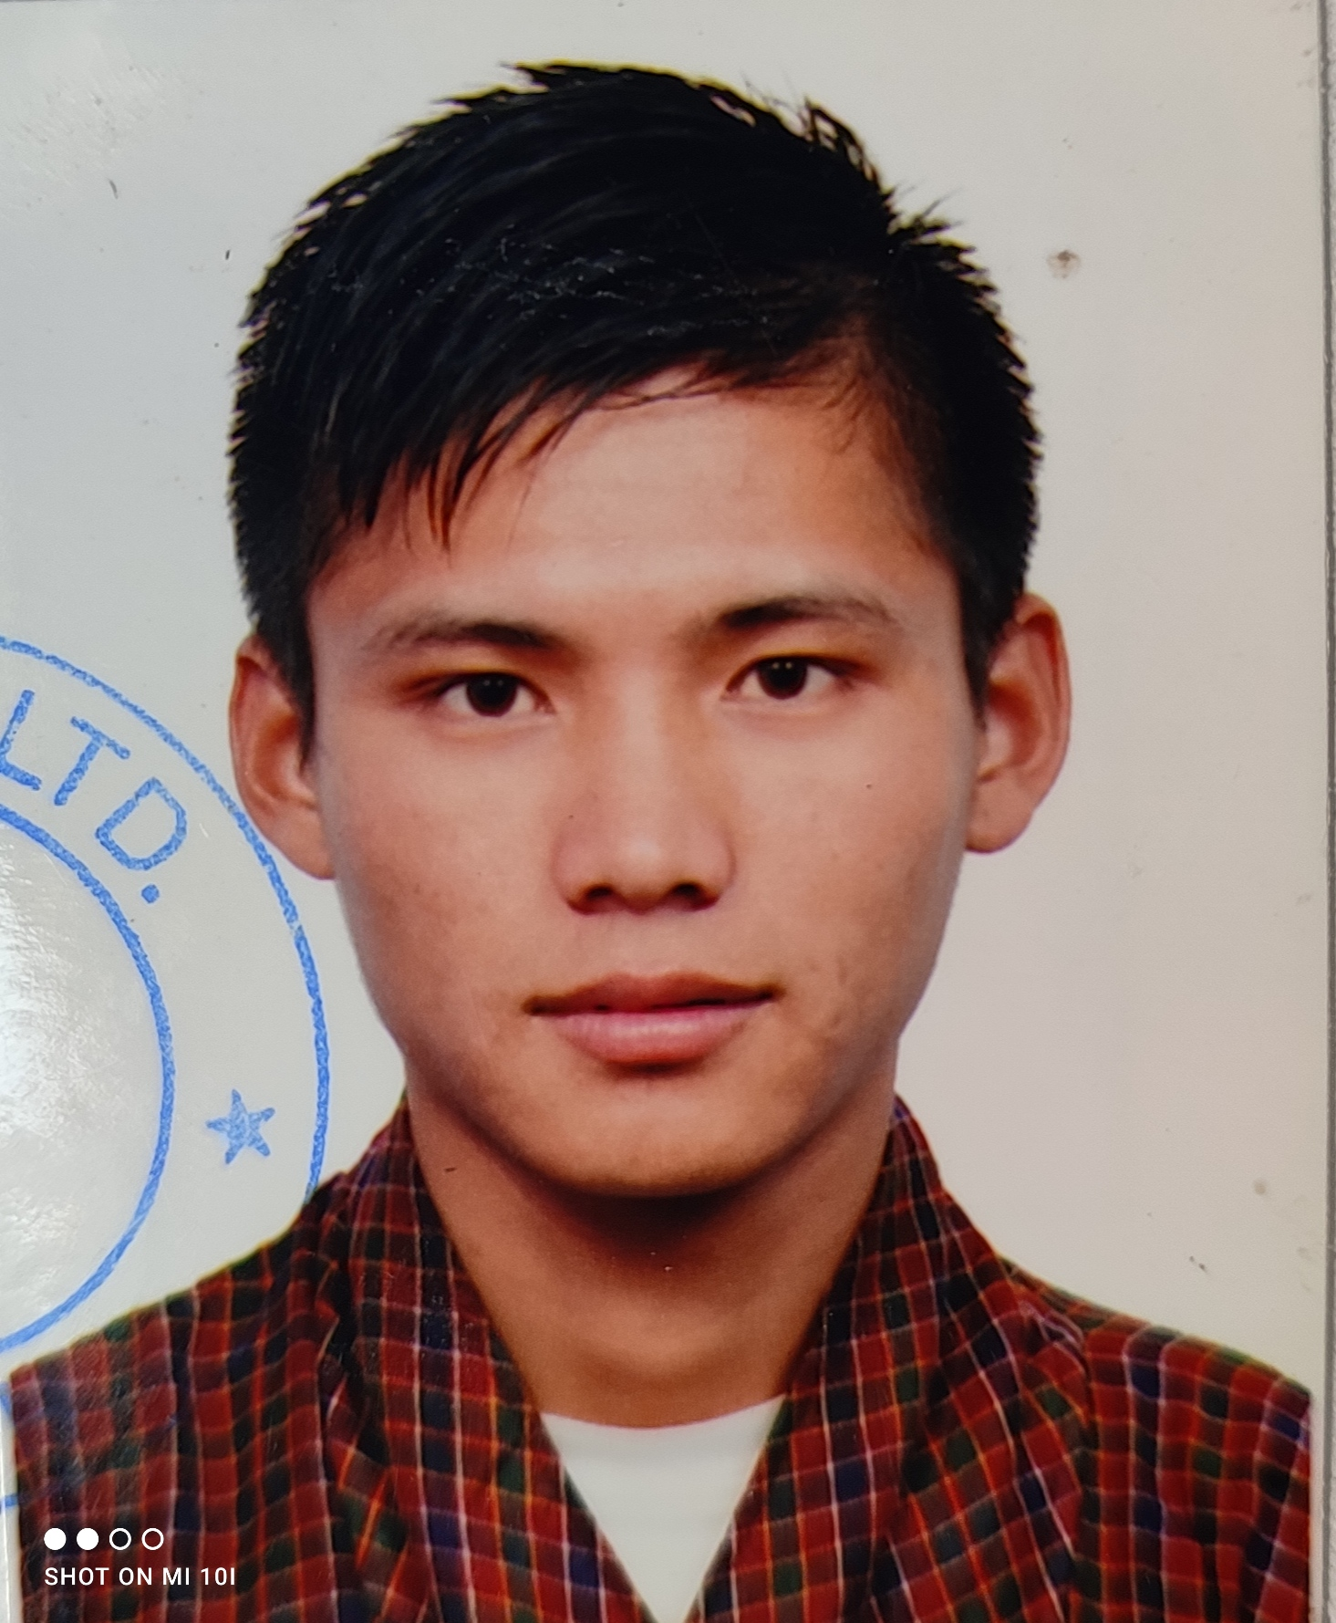 **DHI BUSINESS ACCELERATION FUND**

Attach passport size photos

**APPLICATION FORM**

1. **Personal Information**

Mr/Mrs/Ms: Bal Kumar Monger Age: 30

CID No: 11308001620

Current Address: Geduchhu, Bongo Gewog, Chhukha Dzongkhag

Mobile No: +975 17436571

Email Address: bhutantrouts@gmail.com / blkumrmongr.btn@gmail.com

1. **Primary source of income:**

☐Employment ☐ **✓** Private business ☐Others (please specify) ____________

1. Name of Business and location : Bhutan Trout Farming, Geduchhu Bongo Gewog, Chhukha Dzongkhag
2. Description of business (Maximum of 250 words)

Bhutan Trout Farming is a large scale rainbow trout farm based in Geduchhu Bongo Gewog under Chhukha Dzongkhag. The venture is a sole proprietor ship business, managed and operated by Bal Kumar Monger, founder who use to work as a tour guide before the COVID-19 pandemic. The venture idea is supported by National Research Center for Riverine and Lake Fisheries (NRCR&LF), Department of Livestock under Ministry of Agriculture & Forest. Our company vision and mission are as mentioned;

Vision : To be most vibrant trout supplier in Bhutan

Mission : To include our highly nutritional Bhutanese fish in consumers diet across the globe.

With rapid development and constant increase in meat consumption hobbit adopting western culture. Our main goal is to meet domestic demand, reduce import of fish products from neighboring countries, mention balance of trade by exporting our final products. Especially trout has lots of health benefits as it contains omega fatty acids and it helps young children to grow their mind very fast.

We want to contribute percentage of profit for the community development by helping needy people of the region and students with annual school expenses. We have plans to buy products from farmer and make fish feed from there. As an environment conservation plan we'll be planting around 100 ficus tree annually which will stop water sources from drying up during winter and reduce landslide in the monsoon season, people of the community can cut its branches and feed to their cattle too.

Our products will be sold in the local market first and the remaining excess products will be sold to neighboring countries as per the demand like in India, UAE or Dubai. Export would contribute on national economy by mentioning balance of trade in long term.

1. Select the sector that your business currently operating.

* **✓** Agriculture and forestry
* Construction and Real Estate
* Consumer packaged goods
* Dairy and/or cooperatives
* Education
* Environmental services
* Financial services
* Food and culinary
* Health
* Information technology
* Paper/Packaging
* Transportation
* Textiles
* Tourism
* Waste management and sanitation
* AddOther:_________________________________ (*please specify)*

1. Explain the specific problem or opportunity your business was created to address? (Maximum of 250 words)

My wife gave birth to our first child on 8 October 2018, she was suffering from excessive bleeding after giving birth. We tried several medicines which include both traditional methods and modern medical procedure. My wife health condition was going so bad and it last for more than a month, I was helpless there. Our baby was not getting enough breast milk and had no option than to feed him with lactogen.

My wife was admitted in ward room at Jigme Dorji Wanggchuk National Referral Hospital and one evening I met with a roommate Sonam from Paro who recommended me to feed trout fish soup. Immediately I rush to one of the fisherman house in the same evening, when I share the story and request him for one kilogram of trout fish, he said that "right now I don't have a piece of fish but I promise, I will get at least two to three pieces tomorrow". Next day he got around 5 pieces, which is approximately 1.5 kg, I picked best two pieces, cleaned it well and prepared a sup. I requested my mifw to drink two bowl of the sup with the breakfast. She was well and fit by evening, next day doctor also discharged us from the hospital. Two pieces of trout fish saved my wife and son.

From that day I started doing research about trout fish and finalize to take that as a venture in my life. I did several trials & experiments and all the results are so impressive and saved many people's lives, which include; Assistant Dzongkhag Engineer, Chhukha Dzongkhag who suffer from stroke recovered so well after feeding him with trout sup for three months. Sonam Tshering sir and his family members from piles and constipation. Madam Kezang Deki who works in National Land Commission, Head office Thimphu recovered so well after giving birth to her first daughter. And madam Sangita Pradhan who works in Bank of Bhutan recovered so well after giving birth to her daughter.

The medical values and know that I have about trout fish; I want to share with the people who are residing in different corner of our country and across the globe. I want to extend my knowledge to all the birth giving mother across the globe to give healthier birth life.

1. What stage is your business activity/service in?

* Proven concept
* Initial prototype/early market testing
* Advanced prototype/Obtained market testing results
* **✓** Testing concept, early marketing, certification completed for commercial use and construction going on
* Being sold in the market

1. What is the status of your business? (You can tick more than one)

* Already in the market (obtained license)
* **✓** Expect to commercially launch in the next 6 months
* Expect to commercially launch in 7-12 months
* Expect to commercially launch more than 12 months
* Not yet decided

1. Additional details about your business:
2. What is your revenue for the last three months (in ngultrum)?

_Not started yet OR At construction Phase____________________

1. Who is your current customer target segment?

All the health conscious people, tourist standard hotels, local restaurant, boarding school, colleges, training institutes & fish outlets across the country.

1. Number of current customers _________________
2. When did you start your company (specify date)? 29 April 2020
3. How much money have you already invested in your business so far? More than 3 million and NRCR&LF will be helping us with 7.4 million as a grant.
4. How did you raise finance for your business?

Enterprise development scheme, grant from NRCR&LF Department of Livestock, Ministry of Agriculture and Forest and contributing from my personal savings.

1. How many employees have you hired? Planning to hire 7 in total
2. Who is on your team? (You can tick more than one)

* **✓** Accountant
* **✓** Finance head
* **✓** Operation head
* **✓** Hygiene and quality control
* **✓** Fish feeder & night Guard
* **✓** Technical expert (NRCFR&LF, Haa Fishery Officials)

1. What is the biggest challenge you are currently facing to the successful commercialization of your business? *(Maximum 150 words)*

Bhutan Trout Farming is at construction stage at the present movement and as of date we have completed around 20% of the entire work. Our target is to complete entire construction work within 31 O toner 2022. The joint study and a research carried out by National Research Center for Riverine and Lake Fisheries (NRCR&LF) in collaboration with Chhukha Dzongkhag livestock sector is found out to be very suitable and perfect for large scale rainbow trout farm. Geduchhu, our site has clean and sustainable water source will consistent weather condition throughout the year. Our project is supported by NRCR&LF on cost sharing mechanism guidelines 2021.

As per Department of Livestock enterprise development scheme, Cost Sharing Mechanism guidelines 2021, the center (NRCR&LF, Haa fishery) will help entrepreneurs to construct water supply system and up to eight ponds as dimension mentioned; length 20 meter, breathe 2 meter and height 1.5 meter but we have requested the Department and constructing 12 ponds with bigger dimension as mentioned; length 30 meter, breathe 3 meter and height 1.5 meter with a goal to goal to produce 28 t0 30 metric tons of rainbow trout fish annually. But the department agreed to finance our project with bigger dimension but not with extra four ponds. Department will finance for water supply system and 8 ponds only.

We are supposed to construct 2 unit staff quarter, manager's quarter, office attached with feed store a dressing room facilitity. Constructing fencing for 3.5 acres of government leased land, connecting our site with electricity, installing CCTV and street lights is out responsibility too but I have very less budget to complete all this works. Tried to get loan from CSI Bank and BDBL NCGS but all the bank rejected my farm application form by saying that, "Your proposal don't qualify, as Government is partially financing your project as a grant'

With the amount I receive from DHI BizAP, I will construct additional four ponds although one ponds cost around 290,000 (two hundred and ninety thousands) but we'll try to complete three to four ponds. With construction of additional four ponds, we can produce additional 7 to 10 metric tons of rainbow trout fish annually and employment 2 to 3 additional employment opportunity within the region. Exporting our final product to neighboring countries, we can contribute 2 to 3% on national economy or mention balance of trade of our country. Our farm will encourage and motivate young generation to enter into large scale farming or modern farming.

Total project cost is around 9.26 million, from which 7.4 million is a grant from National Research Center for Riverine and Lake Fisheries. 1.2 million is owner's contribution and we need around 0.7 million to complete the entire project. We are expecting around 1.6 million in the first season which makes around 6.5 million revenue in the first year with four major harvest. DHI support would be great help for our project & we can pay back the entire amount within 5 years of time.

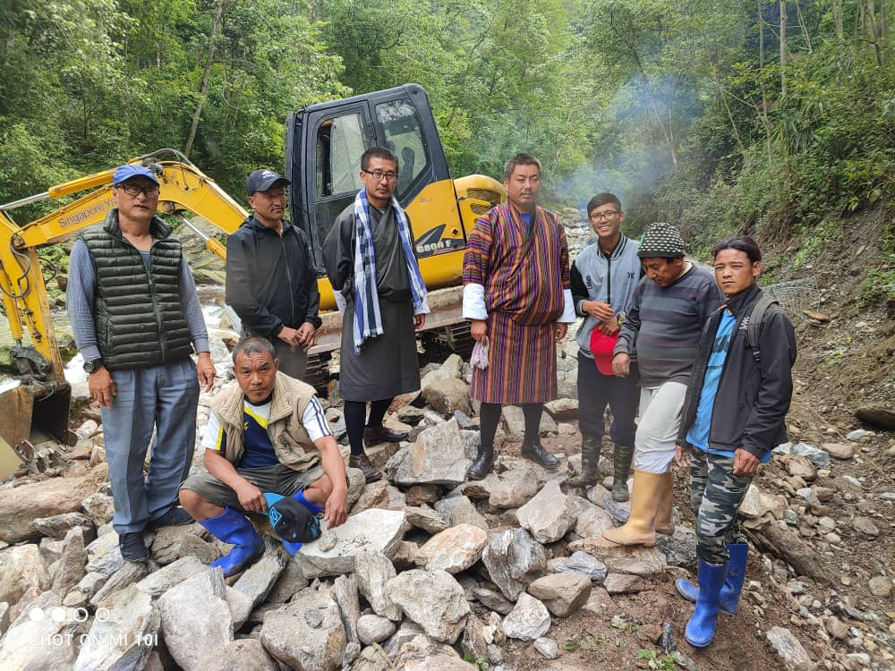

1. What specific resources do you require in order to expand/grow your business? *(Maximum 150 words)*

With support from Bongo Gewog agriculture extension officer, “A Million Fruit Tree Plantation Project” provided us with more than 30 fruits siblings which include; mango, orange, litchi, dragon fruit, peach, pear, plum and many more) and we have already finish with plantation too. Planting fruit tree within and around the farm will look so beautiful when it bloom's during spring season and creates perfect working environment when it gives fruits in summer and autumn season.

Bhutan Trout Farming is a modern rainbow trout farm, supported by Department of Agriculture Marketing Cooperatives with the first and the largest ICE manufacturing unit in Bhutan. Department of Cottage and Small Industry is helping our farm with automatic fish packing machine on a cost sharing mechanism and Chhukha Dzongkhag livestock sector is also helping us with fish smoking chamber. We have modern and most advance facilities, we are coming up with diverse product range and we are very much sure that we can provide very good services to our valued customers.

We are targeting to export our final products (Fresh or chilled vacuum packed rainbow trout fish, Apple or peach flavored smoked rainbow trout fish and customized rainbow trout fish) to different parts of India and UAE. Exporting our final products to neighboring countries will help to mention balance of trade and contribute on our national economy.

Our company will be using marketing mix channels to deliver and reach different outlet of our country. Our products will be vacuum packed and labeled at an international standard. We will be keeping same MRP across Bhutan keeping in mind that our goal is to carter good services to our valued customer rather than to make profit from the very beginning.

As mentioned above, if we can construct more number of fish ponds then we can grow more fish, sell more amount of fish and generate more amount of revenue. The revenue goes to the village or the community people as; monthly salary, part time wages to youth, staff quarter house rent, payment for vegetables and fish feed. Annually when our fish product increases, revenue of the community people will also increase. In this way we can build a very good relationship with the people of the community as our company slogan is "Grow by helping community" and here is our green design.

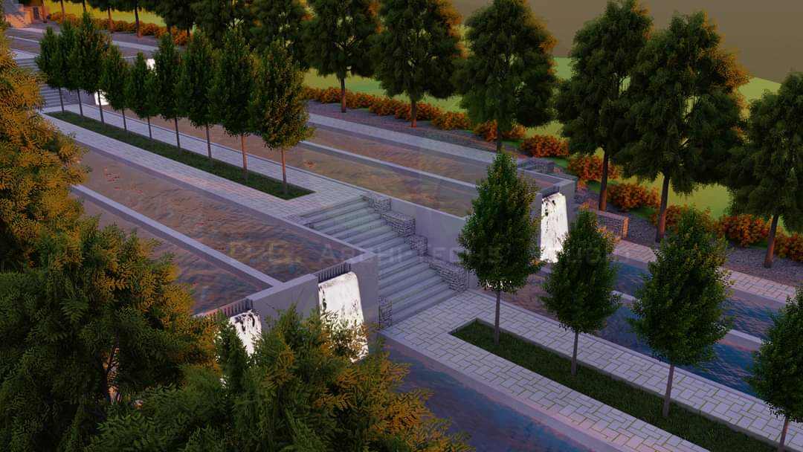

1. Is there anything else you would like us to know about your business opportunity? (Maximum 150 words)

DHI BizAP financing our project would fulfill His Majesty the Fifth Druk Gyelpo Jigme Khesar Namgay Wanggchuk vision for sustainable and socio economic development as our farm location is in quite remote place under Bongo Gewog. Establishment of our farm would create employment opportunities within the region and motivates youth or school drop outs to take up similar venture.

Especially supporting youth like us would encourage more youths and school dropout to engage in such or similar activities. Such initiative will eradicate unemployment issues in the region. People of the community will get educated and empower with good and consistent income sources. Our initiative will reduce illegal fishing practice across rivers of our country in long run.

Rainbow trout fish has lots of medicinal value for both young and adults, as it contains omega fatty acids which helps child brain to grow very fast. Helps medical conditions adults to keep their pressure and hemoglobin normal as it contains right amount of fat's in the fish body. Rainbow trout fish is grown in clean and fresh water unlike warm water fish which are imported from neighboring countries. We don't use chemical's (formalin) to preserve it to transport.

Exporting our products to neighboring countries would inject foreign currency in our country's economy, contribute on mentioning balance of trade of our nation and driving towards national food self-sufficiency. We'll be working towards preserving salmon fish species. We are giving first employment opportunity to local people for both long-term and short-term employment. Since our company slogan is ”grow by helping community” and here is our company logo.



13. Declaration

By submitting this application, I affirm that the information provided are true and complete to the best of my knowledge. Any false statements, omission of any fact and misrepresentation in my resume, application or any other material, may result in my immediate dismissal from the DHI Funding Process.

I hereby authorize DHI to verify the above information.

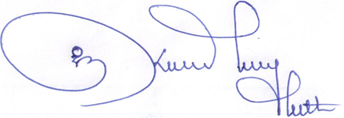

Signature :

Date : 08 May 2022

**Annexure I: Business Proposal Template**

1. Proposed name of the business

***Name of our Venture : Bhutan Trout Farming***

1. Business ownership and location

***Located at : Geduchhu, Bongo Gewog under Chhukha Dzongkhag***

1. Business Description (What is your final product/service?)

***Our company has three final products that are as mentioned;***

* + 1. ***Fresh or Chilled Vacuum packed rainbow trout fish***
    2. ***Peach or Apple flavored smoked rainbow trout fish***
    3. ***Customize vacuum packed rainbow trout fish***

1. Potential Benefits of the business

***Establishment of our farm at Geduchhu has lots of befits as mentioned***

1. ***To local community people as we mention 9.5 km farm road***
2. ***First employment opportunity to local people***
3. ***Part-time employment opportunity to youth and students during vacation***
4. ***Farmer as we buy their farm product like; (maize, pumpkin, peas, beans, grains etc.)***
5. ***Local Youth group/ stakeholders as our property belongs to them once our land lease term is completed (30 years)***
6. ***Health conscious people or fish lover as our fish are grown with best fish hygiene and transportation practice using freezer van.***
7. ***Community people as they get percentage of revenue in the form of House rent and monthly salary***
8. ***Customer across Bhutan as they get fresh and quality fish at a best price***
9. ***Tourist standard hotels as they get quality fish at a best price***
10. ***Government as we will be giving employment opportunity to 7 to 10 youths***
11. ***Government as we will contribute % on balance of trade of our country***
12. ***Youth as our farm is first of it's kind and motivate young generation to take up similar activities in the coming days***
13. ***Plans to give employment opportunity to extra able group of people***
14. Market interest (market opportunities, target and strategy)

Business opportunities

* 1. ***Bhutan government has imported 1079.91 MT (metric tons) of fish product in the year 2020 which is equal to 161.01 million ngultrum (source Kuensel date : 20-04-20)***
  2. ***Our farm is away from the town and the village, we have freedom to work***
  3. ***Farm designed by group of architect, first of it's kind in the country (green design)***
  4. ***Our farm is located very close to Thimphu-Phuentsholing national highway***
  5. ***Drivable distance from our farm to international airport of our country for export***
  6. ***Rainbow trout fish is a salmon species and best for consumption as it contains right amount of fat's.***
  7. ***Trout fish is best for children as it contains Omega fatty acids and it help child to develop their brain very fast.***
  8. ***Trout fish soup is good for people leaving with high blood pressure and agalactia***
  9. ***Bhutanese people adopting western culture and practicing more meat eating habits***

Target customers

1. ***Health conscious people and high profile personal***
2. ***Tourist standard hotels***
3. ***High end local hotels and restaurants***
4. ***Boarding schools, colleges and training institutes***
5. ***Meat and fish outlets across the country***

Marketing strategy

1. ***Social media marketing (Facebook, Twitter, Instagram, What's App etc.)***
2. ***Mix marketing channels (7 P's place, product, promotion, price, packaging, positioning and 0people)***
3. ***Advertisement marketing***
4. ***Camping and social services***
5. Market competition

***As of date there are three private and one government could water fishery far in Bhutan. One in Damthang, one in Tselungkha and one in Paro are small scale rainbow trout farm that produces below 5 tons annually. National Research Center for Riverine and Lake Fisheries, Haa fishery they produce fingerlings only.***

***I believe that, there is no competition as our company and their mode of operation is very different. They harvest only one to two times a year but we do 4 times a year, once in every three months. Moreover there is huge demand for rainbow trout fish in the market. Soon we'll be collaborating and forming a Trout Association of Bhutan. There is enough of market even if 10 new cold water fisheries enter in the market also.***

***To avoid competition amongst trout producer, our farm will harvest before or after other farm harvest their fish, probably keeping one month gap. We’ll focus on producing value added product like smoked rainbow trout fish or customize packing fish.***

1. Risks, barriers and mitigation plan

***In fish farming business there is no such risk associated, if we manage farm with proper sanitation and hygiene. Experiencing contaminated livestock feed this year, huge losses has been occurred to farmers across the country. For that reason as mentioned above, we want to buy ingredients from farmer and process our own feed within two to three years of time.***

***Similarly we will be starting with hatchery facility for fingerling production within the farm by getting hybrid Idova from Denmark since there is tax exemption on import of fingerlings and Idova.***

1. Number of employees and their role

***Our company will be hiring seven associates including myself as a founder and here is our team member.***

***Submitted by : Bal Kumar Monger (Founder& the Chairman) 17436571***

***: Dawa (Operation Head) 17803035***

***: Prakash Koirala (Hygne and Quality control) 77460351***

***: Mrs Geeta Biswa (Finance Head) 17421241***

***Brief background of the team members***

***Bal Kumar Monger (Founder/Chairman - Bhutan Trout Farming)***

***I am from Gongtsakha village, Jigmechholing Gewog, Sarpang Bhutan. Completed my diploma in Tourism Management from Royal Institute for Tourism and Hospitality in the year 20016. Placed in Le Meridien Chhukha, Riverfront for four months internship and got employed there in purchase and finance department. After that I work as a freelance tour guide.***

***In the year 20019, July I resigned from job and started online business (E-commerce market platform) with a name tshongdeal.com and that business didn’t go well. In May 2020, as soon as the COVID-19 pandemic hit our country’s economy, I started with the business plan as a post COVID-19 measure. I work as a overall manager or chairman of the company***

***Dawa (Operation Head)***

***He also completed his diploma from Royal Institute for Tourism and Hospitality in the year 20017 with specialize in tour guide. After that he joined Uma, Paro but left him without a job because of the pandemic.***

***In mid-April 2020, he agreed to work as operation head of our company, I know him well since we were good friend in the institute before. He will be taking care of fishery farm management by implementing and executing final decision made by the company. All the operation team like farm attendant, caretaker, ESP, etc will report to him.***

***Prakash Koirala (Hygne and Quality control)***

***We studied together in Kabesa primary school in Punakha. We were good friends though***

***he was at a higher grade than me. He was hardworking and dedicated to given task, after completing class 12 he was working as tourist vehicle driver in Bhutan wonderers tour and travel company. When COVID-19 pandemic hit tourism industry, he agreed to work on the project as a hygiene and quality controller.***

***Mrs Geeta Biswa (Finance Head)***

***In the year 2017 and 2018 we worked together at Le Meridien Paro, Riverfront and she have been working there since 2016 as a pre-opening tea. When hotel was shut down because of the COVID-19 pandemic, when I asked her that, “I am starting rainbow trout farm, do you want to work for the company” she replied, “I will work if you give good salary”***

***In that way I selected her as a finance head, she was very hardworking, particular about a single cheltrum and have good relation with suppliers from India, Thailand, Denmark, Switzerland and many more.***

***She will look after overall financial matter of the company and she will prepare company profit and loss account, Balance sheet and even annual audit report of the company. She will make final decision on procumbent of the company assets and any equipment.***

***Note : Rest of the team member (One Feeder, One security/night guard and farm Attendant/gardener) not recruited yet since we are at construction phase, we will recruit as soon as we finish with construction work.***

1. Technology used in the business

***Not yet decided, we will finalize after completion of our construction work by consulting with or as recommended by National Research Center for Riverine and Lake Fisheries (NRCR&LF), Haa fishery.***

1. Financial analysis to include:
   * Total investment cost (breakdown of how the investment will be utilized also to be shown)

***Total Project Cost***

|  |  |  |
| --- | --- | --- |
| **Sl no.** | **Particulars** | **Amount/ Year** |
| 1 | Fixed Asset Costing | 8705,000.00 |
| 2 | Preliminary Expenses | 246,000.00 |
| 3 | Working Capital | 317,753.00 |
|  | **Total Project Cost** | **9,268,753.00** |

Note : Breakdown of the fund (Loan Amount) receive from Druk Holding and Investments will be used to construct four fish ponds at our farm as estimated by Dzongkhag Project Engineer, Architect and the project Civil Engineer.

***Cost per pond***

|  |  |  |  |  |  |  |
| --- | --- | --- | --- | --- | --- | --- |
| **Sl no** | **Code no** | **Descriptions of work** | **Quantity** | **Unit** | **Rate** | **Amount** |
| 1 |  | Concrete |  |  |  |  |
|  | MT0043 | Sand | 36 | cu.m | 473.0 | 17,028.00 |
|  | MT0145 | Cement | 293 | Bags | 410.0 | 120,130.00 |
|  | MT0070 | Aggregates | 37 | cu.m | 967.2 | 35,786.00 |
| 2 | MR | Reinforcement | 1992 | Kg | 55 | 9,130.00 |
| 3 | MR | Stone | 24 | Cu.m | 9550 | 19,100.00 |
| 4 | MR | Labour Cost | 355 | Sq.m | 250 | 88750.00 |
|  | **Grand Total** | |  |  | **289,924.40** | |

**Construction cost per pond is 289,924.40 and for 4 ponds = 289,924.40 X 4 = 1159,697.60**

* + Profit and loss statement for 5 years

**Our company Profit and Loss account**

|  |  |  |  |  |  |
| --- | --- | --- | --- | --- | --- |
| **Particulars** | **1st Year** | **2nd Year** | **3rd Year** | **4th Year** | **5th Year** |
| **Sales (A)** | **4333,333.0** | **4766,667.0** | **5243,333.0** | **5767,667.0** | **6344,433.0** |
| **Minus (-)** |  |  |  |  |  |
| Raw Material Costing | **1260,220.0** | **1298,027.0** | 1336,967.0 | 1377,076.0 | 1418,389.0 |
| Administration Costing | 49,400.0 | 50,882.0 | 52,408.0 | 53,981.0 | 55,600.0 |
| Human Resource costing | 600,000.0 | 618,000.0 | 636,540.0 | 655,636.0 | 675,305.0 |
| Preliminary Expenses | 246,000.0 |  |  |  |  |
| Depreciation Amount | 750,000.0 | 750,000.0 | 750,000.0 | 750,000.0 | 750,000.0 |
| DHI Admiration cost (loan) 5 % | 105,000.0 | 105,000.0 | 105,000.0 | 105,000.0 | 105,000.0 |
| **Total Cost (B)** | **3010,620.0** | **2727,409.0** | **2880,915.0** | **2941,693.0** | **3004,294.0** |
| **Gross Profit C (A-B)** | **1322,713.0** | **2039,258.0** | **2362418.0** | **2825.974.0** | **3340,139.0** |
| BIT 30% of C (D) | 396,813.9 | 611,777.4 | 708,725.4 | 847,792.2 | 1002,041.7 |
| **Net Profit** | **925,899.0** | **1425,441.6** | **1653692.6** | **1978,182.0** | **2338,097.3** |

* + - Past two years financial performance.
    - Projections for next 3 years.

**Sales forecast for next three years**

|  |  |  |  |  |  |
| --- | --- | --- | --- | --- | --- |
| **Sl no.** | **Production year** | **Production per year** | **Increase %** | **Rate** | **Total Amount** |
| 1 | 1st year production | 6,666.00 | - | 650 | **4333,333.0** |
| 2 | 2nd Year Production | 7,333.34 | 6% | 650 | **4766,667.0** |
| 3 | 3rd Year Production | 8,066.00 | 9% | 650 | **5243,333.0** |

* + Sales pipeline (this indicates future sale prospects)

|  |  |  |  |  |  |  |
| --- | --- | --- | --- | --- | --- | --- |
| **Sl no.** | **Product** | **Production / Season** | **Production (KG)** | **Amount/ Kg** | **Amount / Season** | **Total Amount/ Year** |
| 1 | Trout Fish | 5,000 nos | 1667 | 650 | 1083,550 | 4,334,200.00 |
|  | **Total Sales per year** | | |  | **4,334,200.00** | |

**Annexure II : Professional Recommendation / Customer Testimonial**

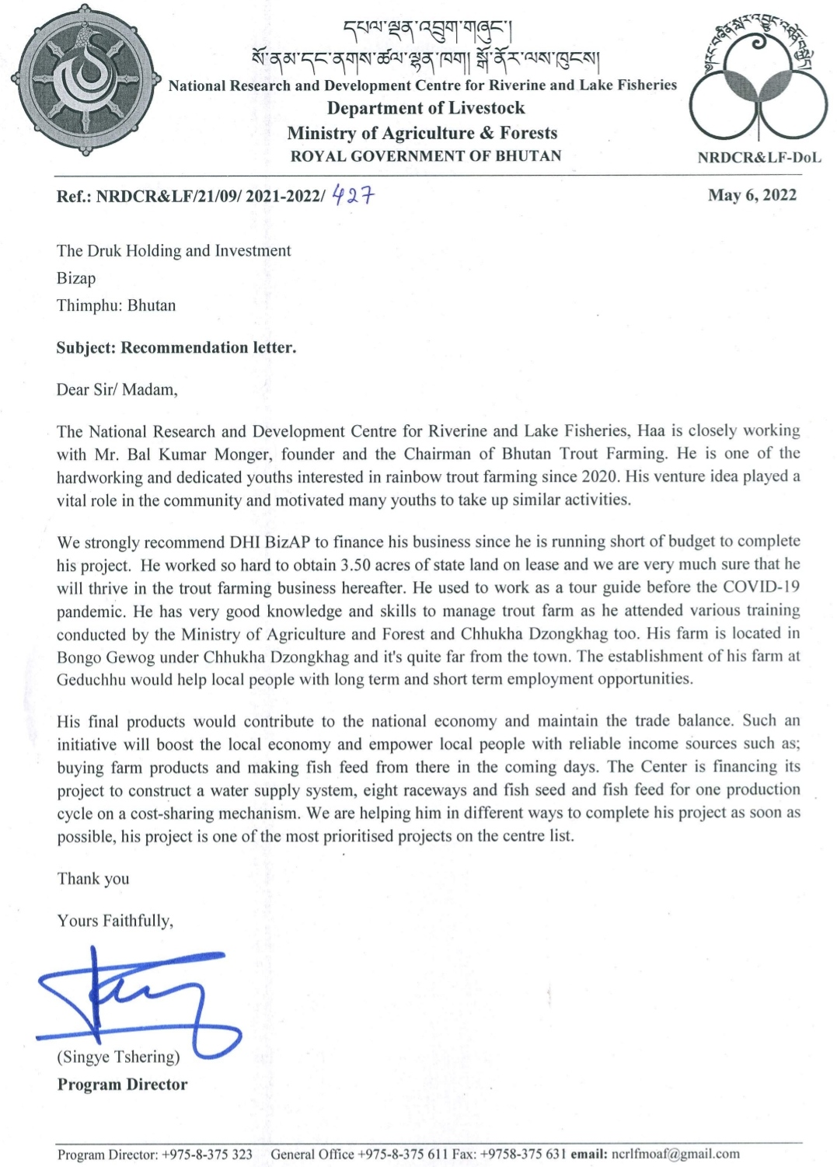

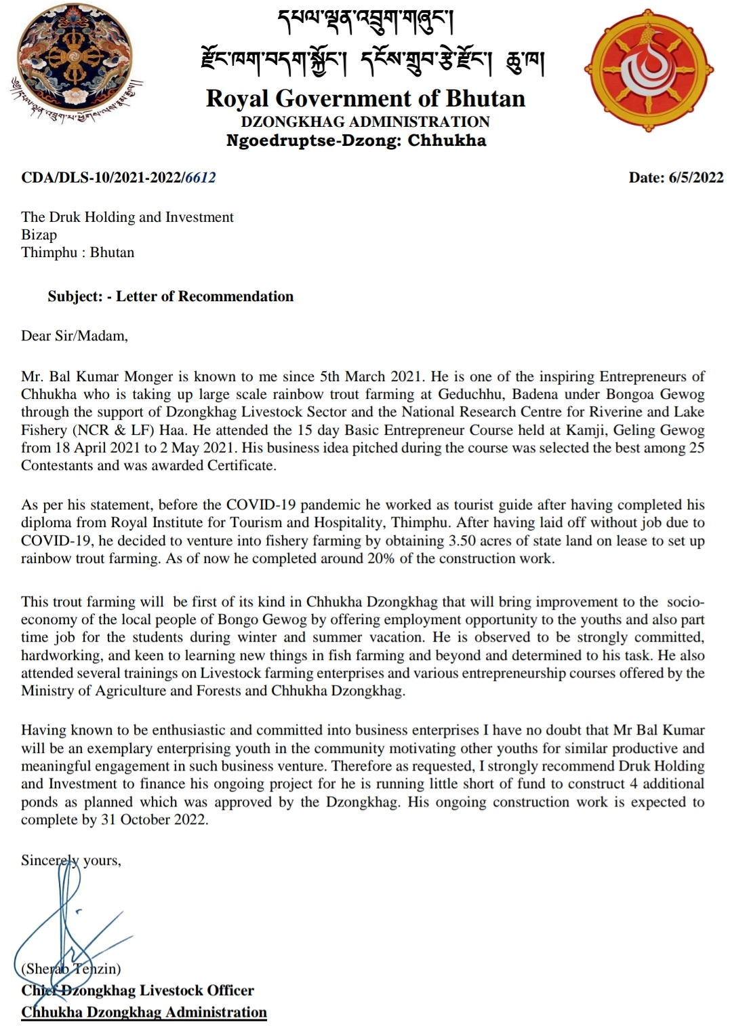

Mail Adress : stenzin@chhukha.gov.bt

Contact no : +975 17626693 / 77308161

Date : 6 May 2022

To,

The Druk Holding and Investments

BizAP

Thimphu : Bhutan

Customer feedback or testimonials

Dear Sir/Madam,

My name is Sonam Tshering, I work for Tourism Council of Bhutan and I am customer of Bhutan Trout Farming. I have known Bhutan Trout Farming, an start up fish farm at Geduchhu being promoted by Mr. Bal Kumar Mongar (Founder & the Chairman). I knew Mr. Bal through friend of mine and we become so close by buying trout fish from Paro for several times. Developed our friendship, shared about business idea, discuss about the future market prospect of the fish farming venture and I encourage him to take it as a lifetime venture two years back.

I believe that, he is one of the few inspiring and hardworking young entrepreneurs in Bhutan. The trout fish farm promoted by him would uplift and enhance self sufficiency of our country livestock product in the local economy. Export of trout fish to other countries would boost local economy and empower local people of the community.

I was a customer at one point of time having experience buying trout fish from him. Trout fish that I bought from him was loved by all my family members and has lots of health benefits too. It has helped my wife for regular period flow and my piles & constipation gets better after enjoying a lovely meal with a trout soup.

I still believe that, the fish produce by his farm will be excellent in term of quality, taste, size and hygiene. In coming years as it produces more trout fish in the market, customers buying the product from his farm would love to order more and visit his farm. I believe that, the farm he own will become one of the key inspirational to the young generation to drive them towards modern farming.

Thank you

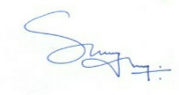

Sonam Tshering (Customer)

Mail adress : drukpasonam123@gmail.com

Phone no : +975 17 97 14 78

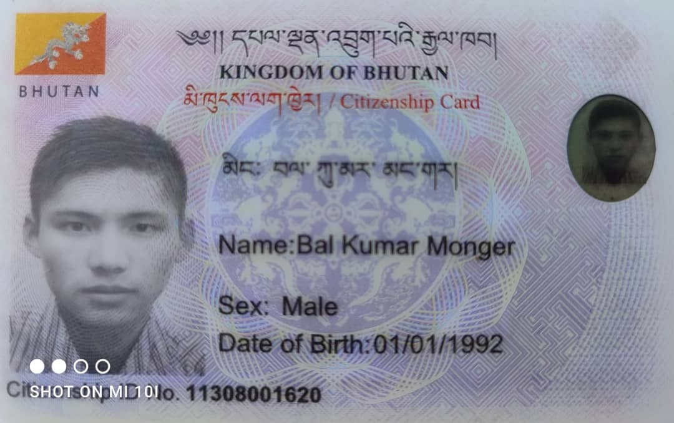**Supporting Documents**

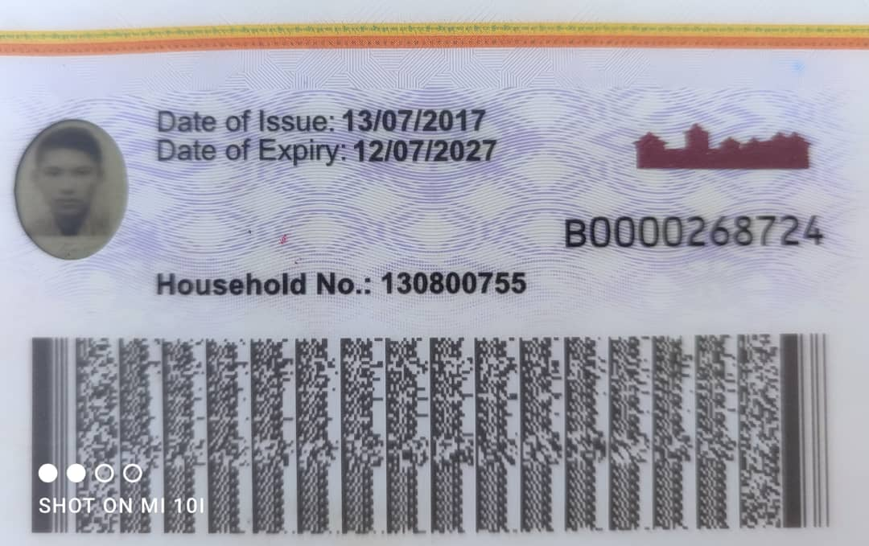

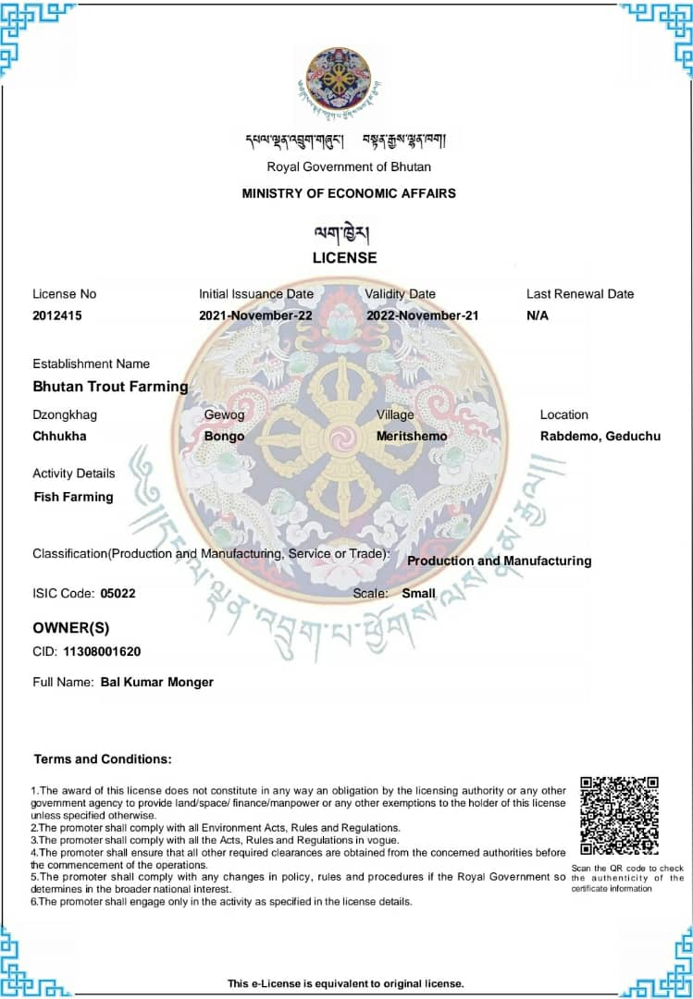

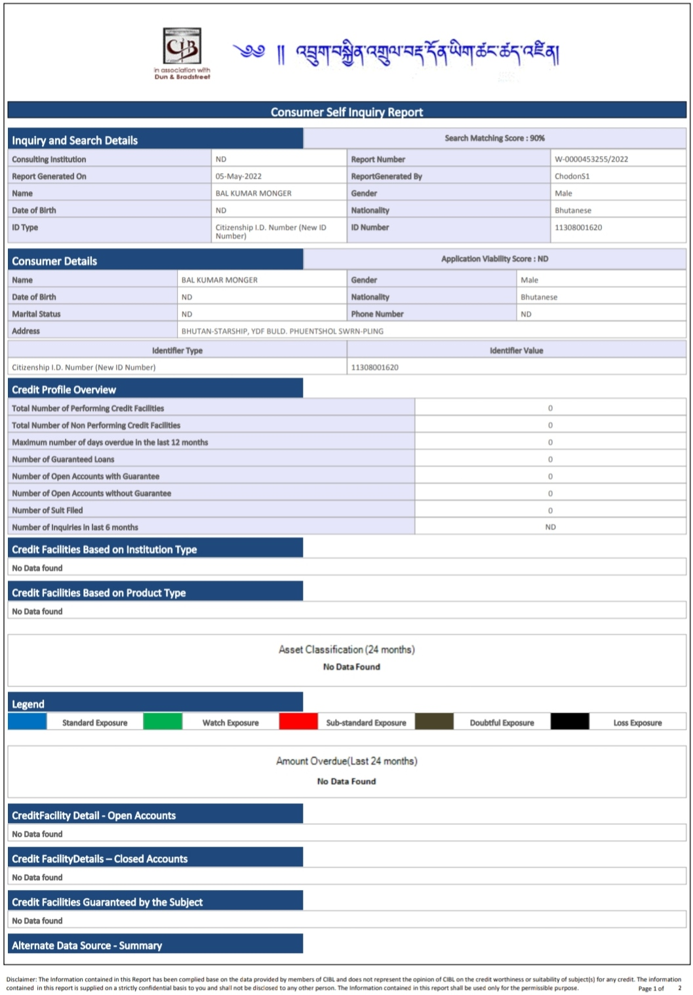

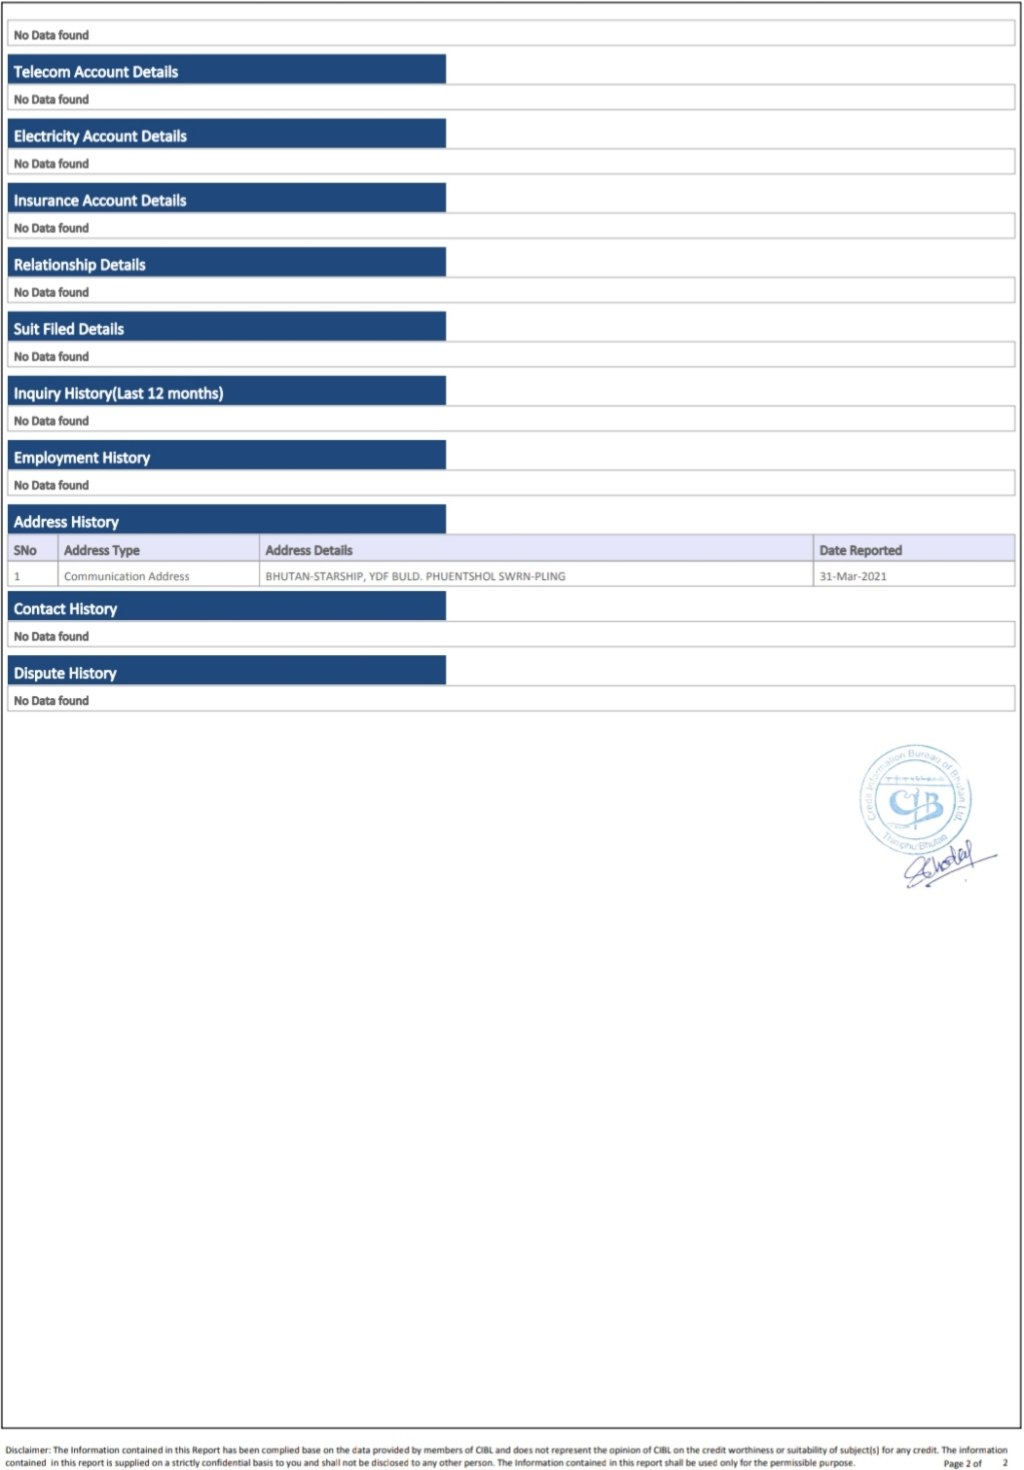

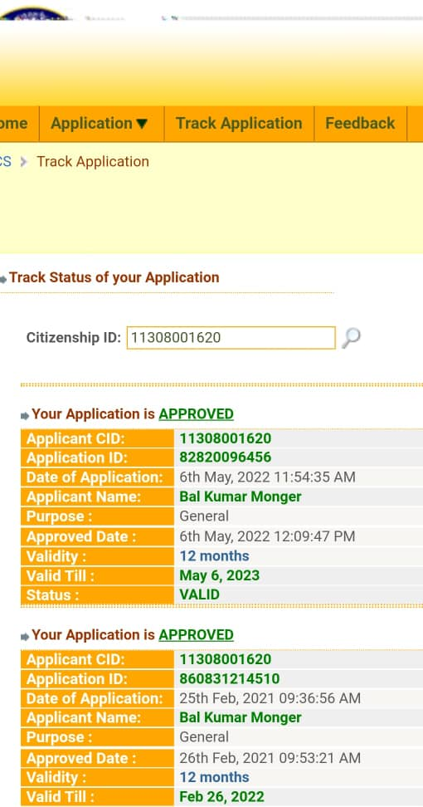

**Curriculum Vitae**



Name : Bal Kumar Monger

Citizen ID no : 11308001620

Highest Qualification : Diploma

Village : Hokaling

Gewog : Jigme chholing

Dzongkhag : Sarpang

Contact number : +975 17436571

Email Adress : [blkumrmongr.btn@gmail.com](mailto:blkumrmongr.btn@gmail.com)

I am very hardworking and dedicated to given task, I am goal oriented. I was very different from my mates since my school days and till date.

I do things in very different day even a very difficult thing, I try to solve in very simple way.

**Hobby**

To watch Hollywood movies as I am very poor in reading short story, novels and journal books. I love listening to mighty 90’s songs at a very loud volume while I drive for long journey.

**Skills**

I have learned a lot about livestock farming through various trainings provided by Ministry of agrieculture and forest and Chhukha Dzongkhag. Got a chance to visit various cold and warm water fishery in Bhutan which include National Aqua Center for Aquaculture in Gelephu, National Research Center for Riverine and Lake fisheries in Haa and many more across the country.

I got driving license and I can drive so well which include two wheeler, light vehicle, heavy vehicle and a excavator at the work site. I have good IT knowledge, I can type Dzongkha as well. I have goo PR (public relationship) and build good relationship with all kinds of people at any place.

**Marital status**

I am married and have two kids, one son and one daughter. Elder son is two and half year and younger daughter is six months old.

**Qualification**

Diploma in Tourism and Hospitality from Royal Institute for Tourism and Hospitality, Motithang; Thimphu : Bhutan. Specialize in tourism management in the year 2016

BHSEC from Kuendrup Higher Secondary School, Gelephu in the year 2013 with commerce background.

**Work Experience**

I worked as a sales manager for O Globo Bhutan for southern region at Gelephu for six months in the year 2014

I worked as a purchase assistant manager at Le Meridien Paro, Riverfront from September 2016 to July 2018.

I worked as a freelance tour guide for three months before the COVID-19 for keys to Bhutan and Rainbow Tours and travel in Thimphu.

**SWOT’s**

|  |  |
| --- | --- |
| **Strength** | **Weakness** |
| I am very hardworking | I cannot except untrue to be true |
| I can adjust in any kind of environment | I am very straight forward |
| I got good knowledge about livestock farming |  |
| **Opportunity** | **Threats** |
| I always look for opportunity and grab it | I take lots of risk |
| My wife and family member are very supportive | Goal oriented |
| I can convince people very well |  |

**Training attained**

Attend 10 days training at National Research Center for Riverine and Lake Fisheries on cold water fishery farm management

Basic Entrepreneur Curse at Kamji, Geling Gewog for 15 days conducted by Chhukha Dzongkhag

One week training conducted by Youth Employment and Rural Entrepreneurship (YERE) by Department of Agrieculture at Gedu

Week long training conducted by Loden Foundation at Youth Center, Phuentsholing in the year 2020 for seed fund.

**Decleration**

I affirm that the information provided above are true and complete to the best of my knowledge. Any false statements, omission of any fact and misrepresentation in my curriculum vitae can be checked and verified

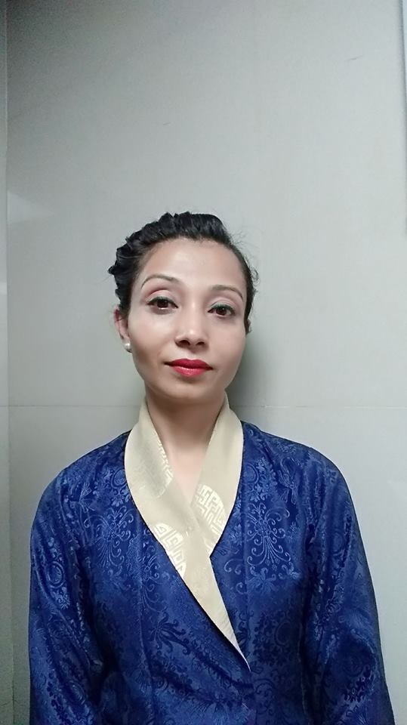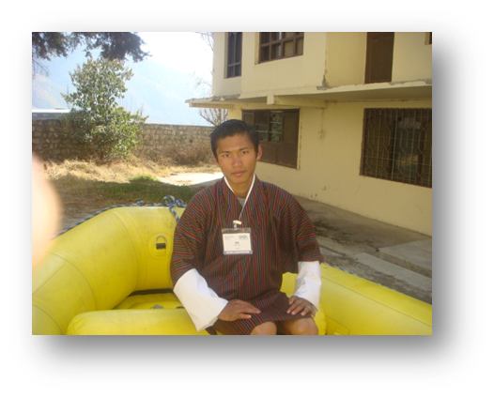 CURRICULUM – VITAE

**GEETA BISWA**

Village : Tashipang

Gewog : Mendrelgang

Dzongkhag : Tsirang Dzongkhag;

Mob. No + 975 17421241Bhutam

Email. ruth.rozi57@gmail.com

**PERSONAL PROFILE:**

Father’s Name : Mr. Mandhoj Biswa

Date of Birth : 16th Nov 1987

Hobbies : Room Decoration, Play music and games

Language Known : English, Hindi, Nepali & Bhutanese.

**CAREER OBJECTIVE:**

To build career in a growing organization, where I can get the opportunities to prove my abilities by accepting challenges, fulfilling the organizational goal. And climb the career ladder through continuous learning and commitment.

**PROFESSIONAL QUALIFICATION:**

* Completed 3 years Diploma in Hotel Management from RIMS School of Hotel Management, Kolkata.

**ACADEMIC CREDENTIALS:**

* Completed class 10 from KHASADRAPCHU MIDDLE SECONDARY SCHOOL, BHUTAN.
* Completed 12 from NIMA HIGHER SECONDRY SCHOOL, Thimphu BHUTAN.

**EXPERIENCE REVIEW:**

* 6 Month Work Experience in **Radission White Send** Resort Goa as Industrial Training.
* Worked with **Oberoi Grand Kolkata** as a Housekeeping Attendant from 1st June 2011 to 1st June 2014.
* Worked at **Oberoi Grand Kolkata** as a Housekeeping supervisor from 1st July 2014 to 30th May 2015.
* Present working with **Le Meridien Paro, riverfront** as a Housekeeping supervisor from 1st September 2015 till Date.

**PRESENT RESPONSIBILITIES INCLUDES:**

* Perform monthly evaluation for staff and give feedback and suggestion for improvement
* Provide training to staff and give motivating comments to new enrolment
* Work well and efficient as a key player for the organization.
* Conduct monthly department meeting to share their achievements & success then discuss what they can do better to exceed guest expectation.
* Checking rooms for VIP and long staying guest.
* Supervise the daily public area schedule.
* Identifying cost control measures without compromising the quality service.
* Daily check departure rooms in the system and release for the arrival.
* Up keeping of the property to the highest standard.
* Coordinate with front desk for daily arrivals and rooms-on hold for smooth functioning.
* Plan schedule for general cleaning camping during lean season.

**SOFTWARE KNOWLEDGE:**

* OPERA, PMS (Property Management System) and VERSION.
* And other software used in Multinational property especially which are used by Starwood Hotels & Resort.

**Position Preferred:**

* Finance Head or Finance officer.

**Declaration:**

I consider myself familiar with all the above mention aspects. I am also confident of my ability to work as a team. I hereby declare that the information provided above is true to the best of my knowledge.

**References:**

1. Le Meridien Paro, Riverfront Dechen Tshomo (House Kipping Manager) Cont no: +975 17331907
2. The Oberoi Grand Kolkata, India Mr. Abishek Methani, Executive House Keeper Contact: +91 9057059413
3. Le Meridien Paro, Riverfront Yenten T. Lhendup, Restaurant and Bar Manager Cont no: +975 77483074

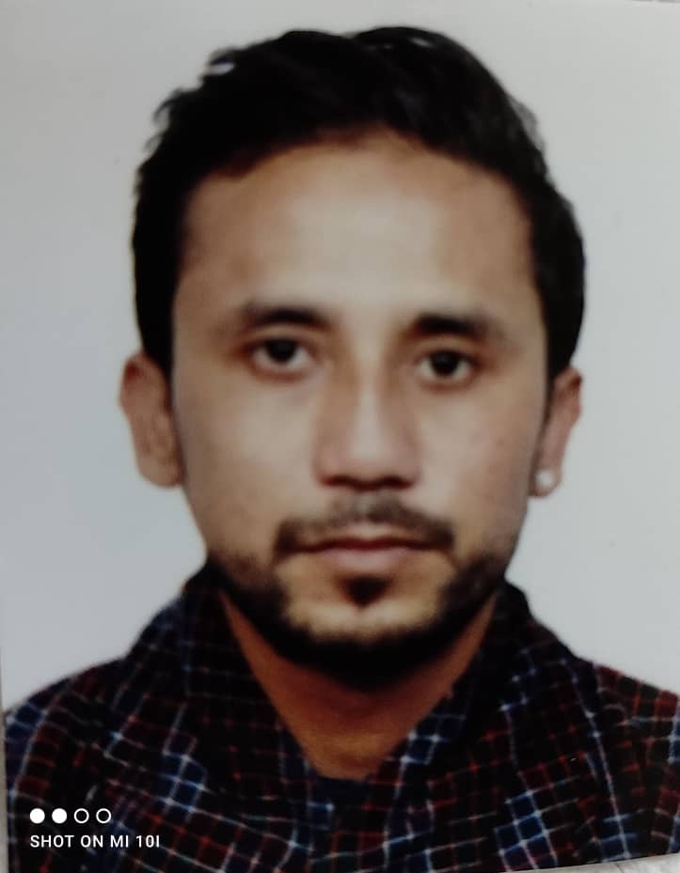 CURRICULUM – VITAE

Name : Prakash Koirala

Citizen Card no : 11303001870

Village : Dekiling

Dzongkhag : Sarpang

Qualification : Class 12

Contact no : +975 77460351

**Experience**

I was born and brought up in warm water fishery farm in Gelephu and I have good knowledge about fish farming. I would love to work as hygiene and quality controller in fishery farm or any company.

I worked as a tourist bus driver for Bhutan Wanderers Tours and Travel, Thimphu before the COVID-19 pandemic

**Maximum Qualification**

Completed class twelve from Reldi Higher Secondary School, Phuentsholing, Chhukha Dzongkhag

**Hobbies and Interest**

I love cleaning, decorating room and designing new things. I love traveling around the globe, I like communicating with people from different parts of the world. I am very particular, hygiene and a healthy living guy.

**Skills and knowledge**

I keep my room, vehicle and equipment as clean as new. I have very good knowledge about hygiene and quality control. During my school vacation, I used to work in Gelephu Fishery farm and learned lots of good things from there.

During my free time also, I always watch various company SOP’s and ISO certification to build my knowledge and skills.

**Declaration**

I am confident of my ability to work as a company Hygiene and Quality controller. I hereby declare that the information provided above is true to the best of my knowledge.

**References**

Owner, Bhutan Wonderers Tour and Travels contact no : +975 17654844

CURRICULUM – VITAE

Name : Dawa

Citizen Card no : 11303001870

Village : Zhelngo

Gewog : Sharpa

Dzongkhag : Paro

Qualification : Diploma

Contact no : +975 17803035

**Education and Qualification**

Completed Diploma from Royal Institute for Tourism and Hospitality, Motithang specialize in Tourism Management

Completed class 12 from Tenzin Higher Secondary School , Paro

**Hobbies and Interest**

I love and enjoy fishing for days and weeks. I like playing games, especially bad mention and food ball. I enjoy watching movies and listening to rock songs.

**Skills and Knowledge**

I have good knowledge and experience about software used in 5 star hotels which include; SUN, MICROS, OPERA, WinHMS and many more

I have very good driving skills and license too for both light vehicle and two wheeler during emergency time.

**Strength**

I am very straight forward and hardworking man with family member

I have very good knowledge about tourist and foreign guest preference

I can communicate with various peoples in different languages even Thai

I have good PR (Public Relation) within and outside the country

Implement tourism industry know in fish farming also

**Weakness**

I belong to poor family member

Progress oriented and get demotivated when I can’t meet the target

**Threats**

Tourism industry and Animal Husbandry is totally two different industry

Very much interested but no much knowledge about fishery farming

**Opportunity**

I can do lot of better thing in fishery farm

It’s a booming aqua culture industry and I can learn from the web and net

I get lots of opportunity to learn new things

Latest technology are used in the in the industry

I love fish so much

**Declaration**

I hereby declare that the information provided above is true to the best of my knowledge.